 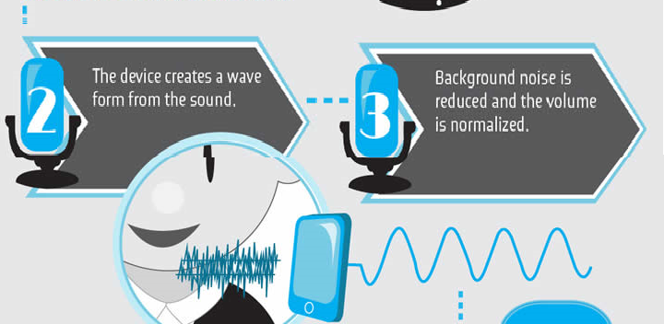

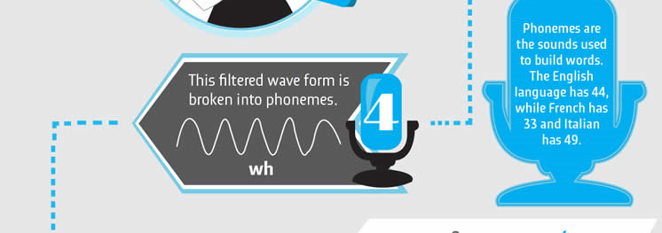

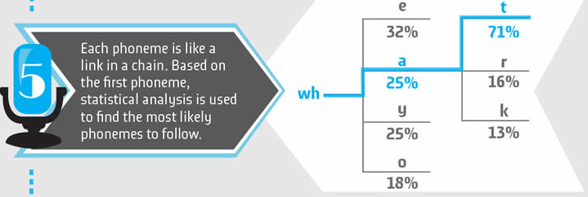

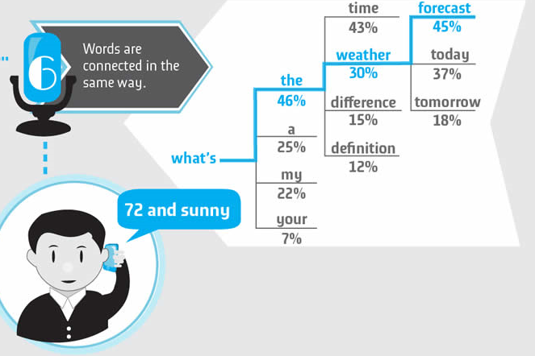

Whatever we speak , each letter or word has a different propery and wave form that is generated differ in shape w.r.t time. So each letter can be uniquely identified in the wave form generated.

At each time , waveform is analysed and according to the frequency we can feed it to the model .this is called short term processing .

For instance, you would understand that I wanted to have a burger, whether I said, ‘I’m in the mood for a burger today’ or exclaimed, ‘If only I could have a large Burger King right here!’ However, a machine wouldn’t be intuitive enough to understand what I’m trying to express.

This is where **Natural Language Processing** steps in; it tries to make Siri as intuitive as a machine can be. And if you’re an iPhone user, you already know that it’s pretty intuitive!

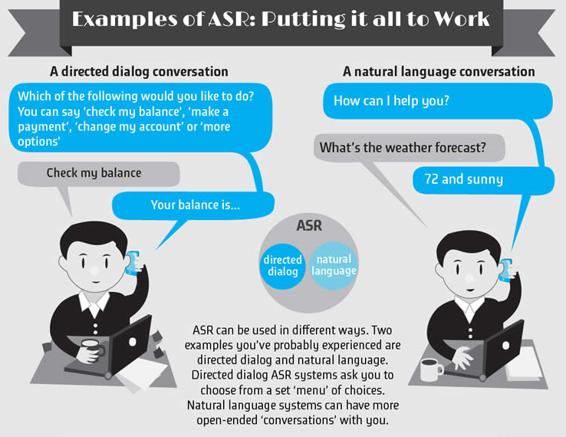

One proposed method of computer interactions is speech recognition. Speech recognition involves software and hardware that act together to audibly detect human speech and translate the detected speech into a string of words. As is known in the art, speech recognition words by breaking down sounds the hardware detects into smaller non-divisible sounds called phonemes. Phonemes are distinct units of sound. For example, the word “those” is made up of three phonemes, the first is the “th” sound, the second is the “o” sound, and the third is the “s” sound. The speech recognition software attempts to match the detected phonemes with known words from a stored dictionary. An example of a speech recognition system is given in U.S. Pat. No. 4,783,803, entitled “SPEECH RECOGNITION APPARATUS AND METHOD”, issued Nov. 8, 1998, assigned to Dragon Systems, Incorporated. Presently, there are many commercially available speech recognition software packages available from such companies as Dragon Systems, Inc. and International Business Machine Corporation.

One limitation of these speech recognition software packages or systems is that they typically only perform command and control or dictation functions. Thus, the user is still required to learn a vocabulary of commands in order to operate the computer.

A proposed enhancement to these speech recognition systems is to process the detected words using a natural language processing system. Natural language processing generally involves determining a conceptual “meaning” (e.g., what meaning the speaker intended to convey) of the detected words by analyzing their grammatical relationship and relative context. For example, U.S. Pat. No. 4,887,212, entitled “PARSER FOR NATURAL LANGUAGE TEXT”, issued Dec. 12, 1989, assigned to International Business Machines Corporation teaches a method of parsing an input stream of words by using word isolation, morphological analysis, dictionary look-up and grammar analysis.

Natural language processing used in concert with speech recognition provides a powerful tool for operating a computer using spoken words rather than manual input such as a keyboard or mouse. However, one drawback of a conventional natural language processing system is that it may fail to determine the correct “meaning” of the words detected by the speech recognition system. In such a case, the user is typically required to recompose or restate the phrase, with the hope that the natural language processing system will determine the correct “meaning” on subsequent attempts. Clearly, this may lead to substantial delays as the user is required to restate the entire sentence or command. Another drawback of conventional systems is that the processing time required for the speech recognition can be prohibitively long. This is primarily due to the finite speed of the processing resources as compared with the large amount of information to be processed. For example, in many conventional speech recognition programs, the time required to recognize the utterance is long due to the size of the dictionary file being searched.

An additional drawback of conventional speech recognition and natural language processing systems is that they are not interactive, and thus are unable to cope with new situations. When a computer system encounters unknown or new networked objects, new relationships between the computer and the objects are formed. Conventional speech recognition and natural language processing systems are unable to cope with the situations that result from the new relationships posed by previously unknown networked objects. As a result, a conversational-style interaction with the computer is not possible. The user is required to communicate complete concepts to the computer. The user is not able to speak in sentence fragments because the meaning of these sentence fragments (which is dependent on the meaning of previous utterances) will be lost.

Another drawback of conventional speech recognition and natural language processing systems is that once a user successfully “trains” a computer system to recognize the user's speech and voice commands, the user cannot easily move to another computer without having to undergo the process of training the new computer. As a result, changing a user's computer workstations or location results in wasted time by users that need to re-train the new computer to the user's speech habits and voice commands.